***PROJECT REPORT TEMPLATE***

1.INTRODUCTION

Overview of Analyzing the Performance & Efficiency of The Radisson Hotels

using Data Visualization Techniques. Analyzing the performance and efficiency of

the Radisson Hotels using data visualization techniques can provide valuable insights

into the hotel's operations and help identify areas for improvement. The following is

an overview of the steps involved in this process: Define the Key Performance

Indicators (KPIs): The first step is to identify the KPIs that will be used to evaluate

the performance and efficiency of the Radisson Hotels. These may include metrics

such as occupancy rates, average daily rate (ADR), revenue per available room

(RevPAR), customer satisfaction scores, and employee turnover rates. Gather the data:

The next step is to gather the data needed to calculate the KPIs. This may involve

collecting data from various sources, such as the hotel's Property Management System

(PMS), customer feedback surveys, and employee performance records. Clean and

process the data: Once the data has been collected, it will need to be cleaned and

processed to ensure accuracy and consistency. This may involve removing duplicates,

correcting errors, and formatting the data in a way that is compatible with the data

visualization tools. Choose the data visualization tools: There are many data

visualization tools available, such as Tableau, Power BI, and Excel. The choice of

tool will depend on the complexity of the data and the level of customization required.

Create the visualizations: The next step is to create the visualizations that will be used

to analyze the data. This may involve creating charts, graphs, and dashboards that

display the KPIs in a clear and easy-to-understand format. Analyze the data: Once the

visualizations have been created, the data can be analyzed to identify trends and

patterns. This may involve comparing performance across different hotels or over

time, identifying areas of high or low performance, and looking for correlations

between different KPIs.Draw conclusions and make recommendations: Based on the

analysis of the data, conclusions can be drawn about the performance and efficiency

of the Radisson Hotels. These conclusions can then be used to make

recommendations for improving operations and increasing profitability. Overall, data

visualization techniques can be a powerful tool for analyzing the performance and

efficiency of the Radisson Hotels, and can help identify areas for improvement that

might otherwise be overlooked. PURPOSE: Uses of Analyzing the Performance &

Efficiency of The Radisson Hotels using Data Visualization Techniques Analyzing

the performance and efficiency of Radisson hotels using data visualization techniques

can provide several benefits. Here are some potential uses of such an analysis:

Identifying trends: Data visualization can help identify patterns and trends in the

hotel's performance, such as occupancy rates, revenue, and customer satisfaction. By

analyzing this data over time, hotel managers can identify areas for improvement and

make data-driven decisions. Comparing performance: Data visualization can also be

used to compare the performance of different Radisson hotels, such as those in

different regions or countries. This can help identify best practices and areas where

one hotel is performing better than others. Overall, analyzing the performance and

efficiency of Radisson hotels using data visualization techniques can help hotel

managers make data-driven decisions, improve customer satisfaction, and drive

business growth. There are several potential benefits that can be achieved by

analyzing the performance and efficiency of Radisson hotels using data visualization

techniques. Here are a few examples: Improved decision-making: By analyzing data

on key performance indicators (KPIs) such as occupancy rates, average daily rate

(ADR), and revenue per available room (RevPAR), hotel managers can make data-

driven decisions about how to improve the hotel's performance. For example, if

occupancy rates are low, managers may decide to offer promotions or adjust pricing

strategies to attract more guests.

1. EMPATHY MAP

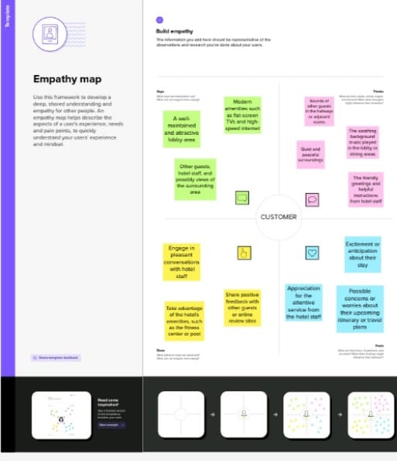

1. BRAINSTROM MAP:

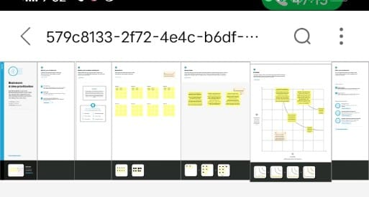

1. TABLEAU PUBLIC

1.REVENUE SPLIT BY CITY

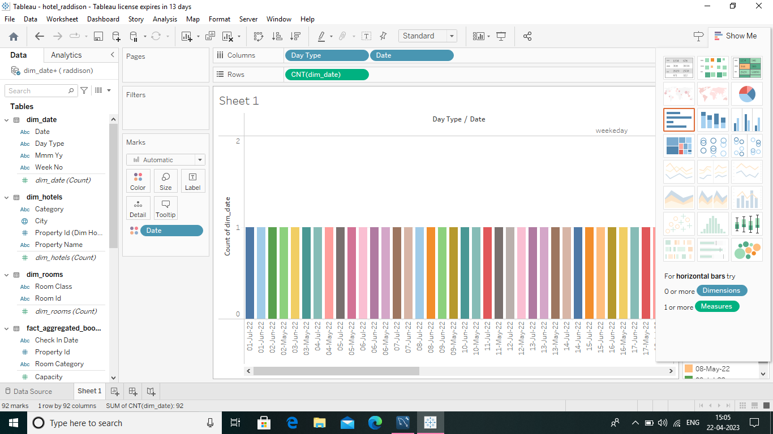

2.OCCUPANCY SPLIT BY CITY:

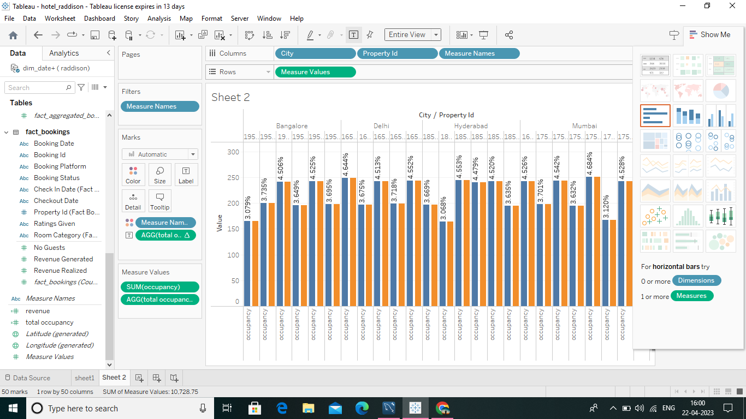

3.OCCUPANCY BY DATA TYPE:

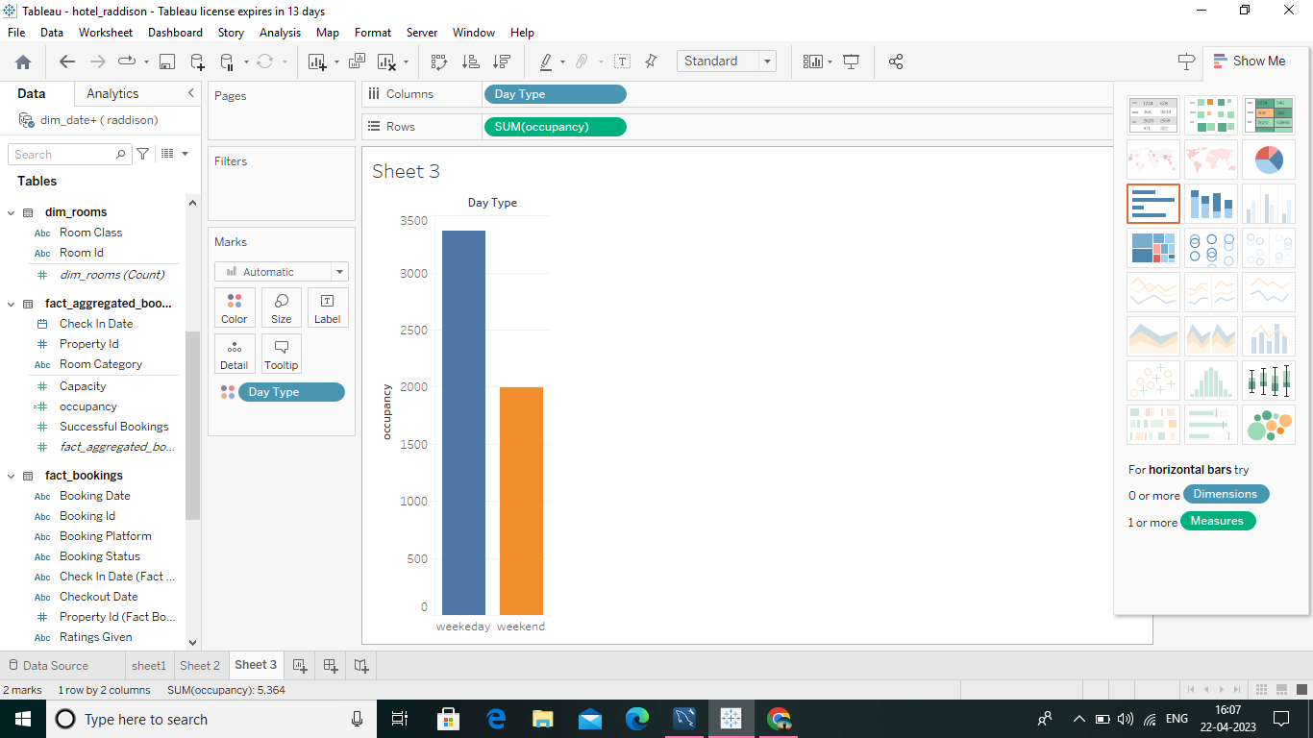

4.Revenue by room class:

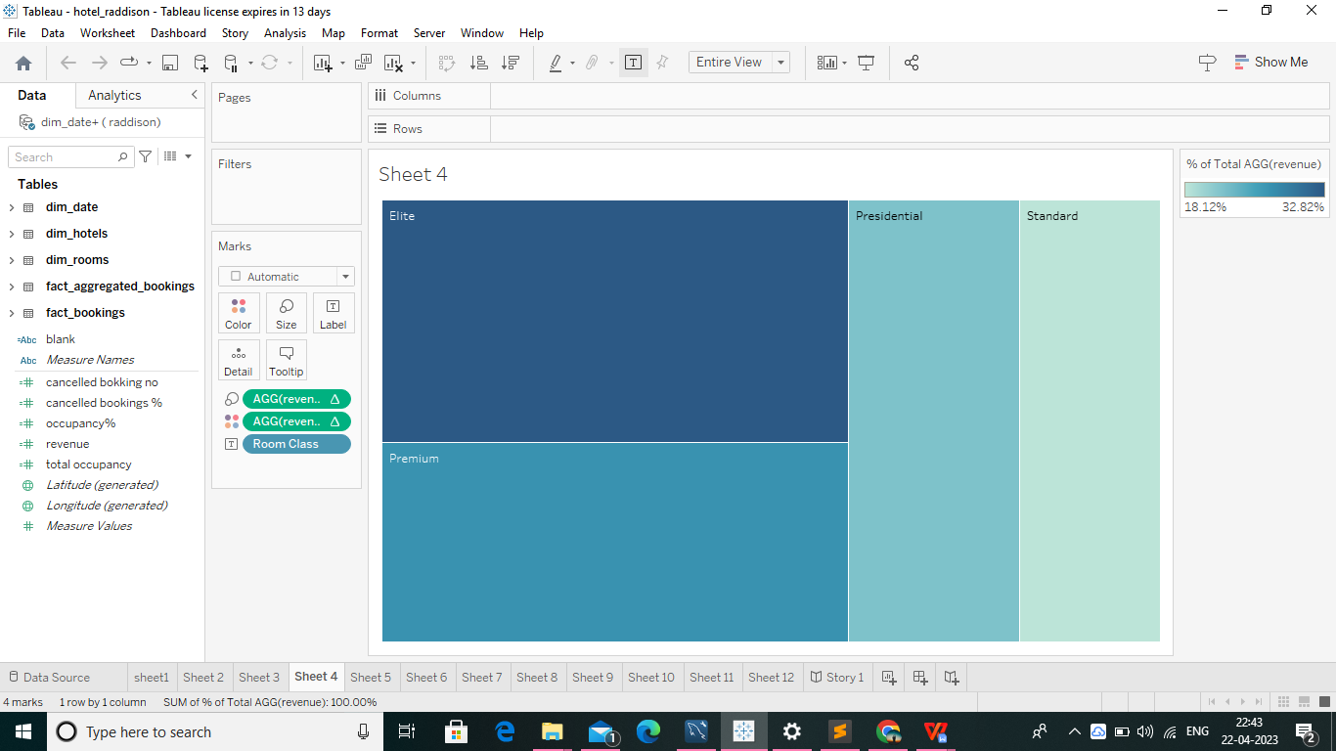

**5.Booking % by platform**

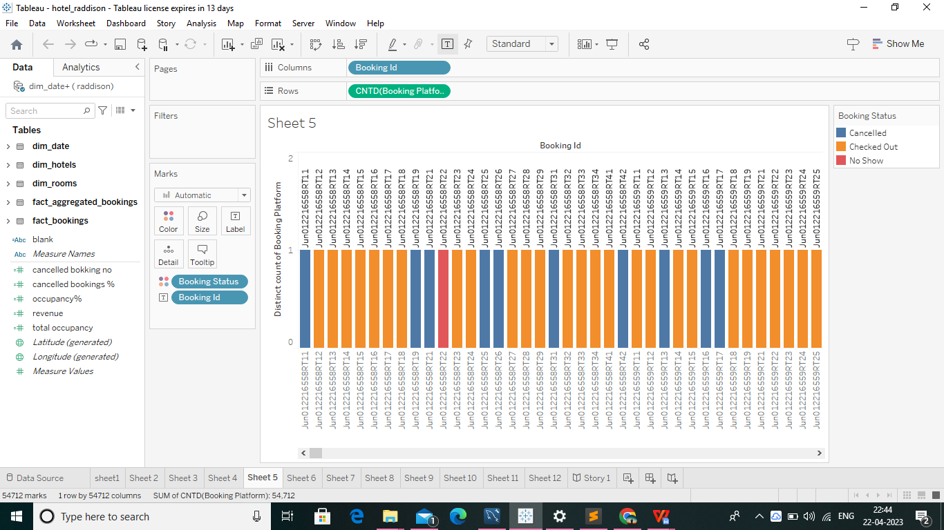

**6.Property By key metrics**

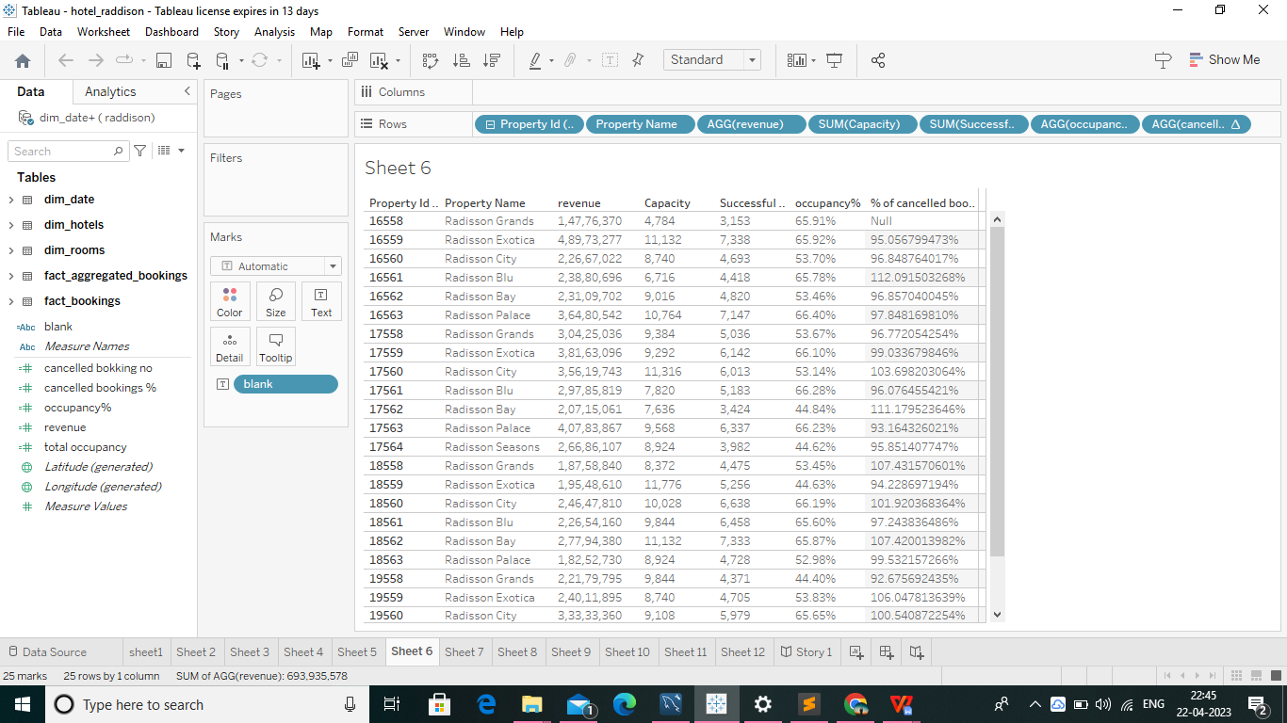

**7.Revenue contribution % by category**

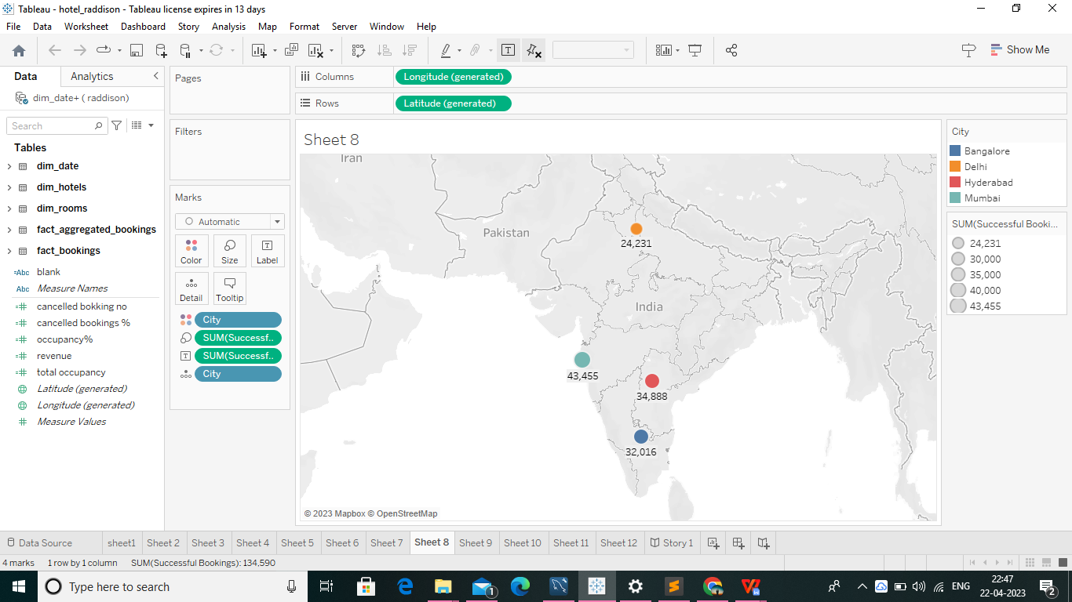

**8.Successful Booking by date wise**

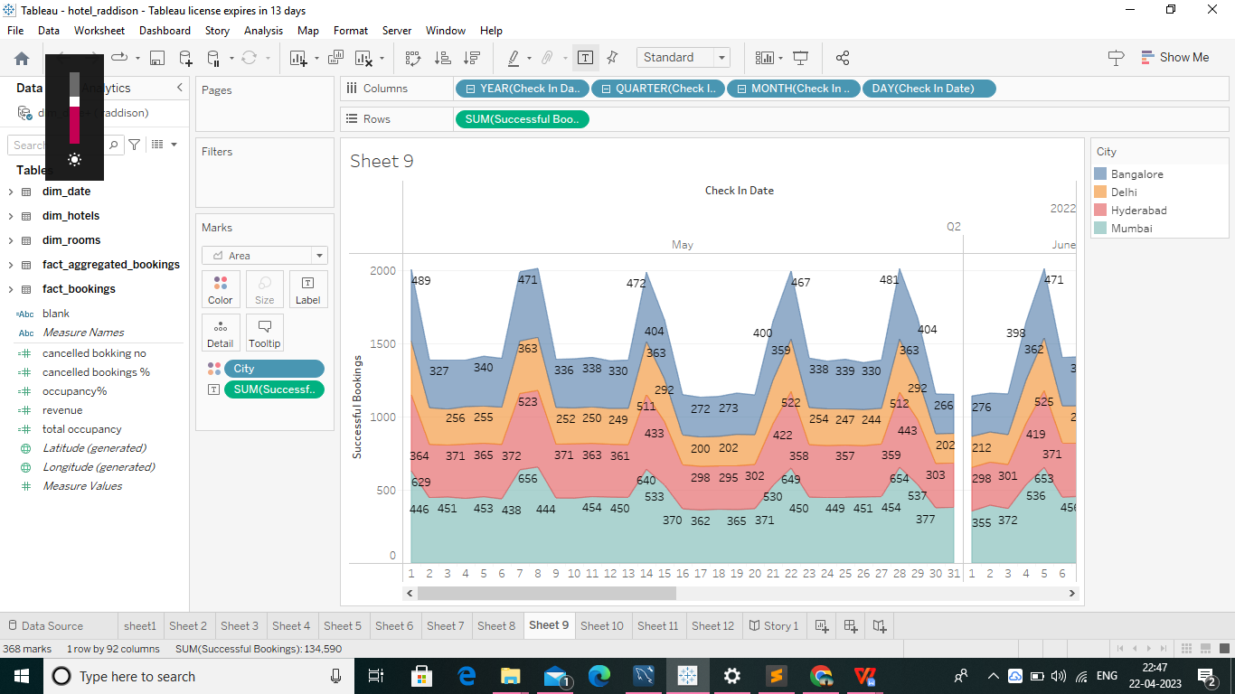

**9.Total Revenue for the hotels**

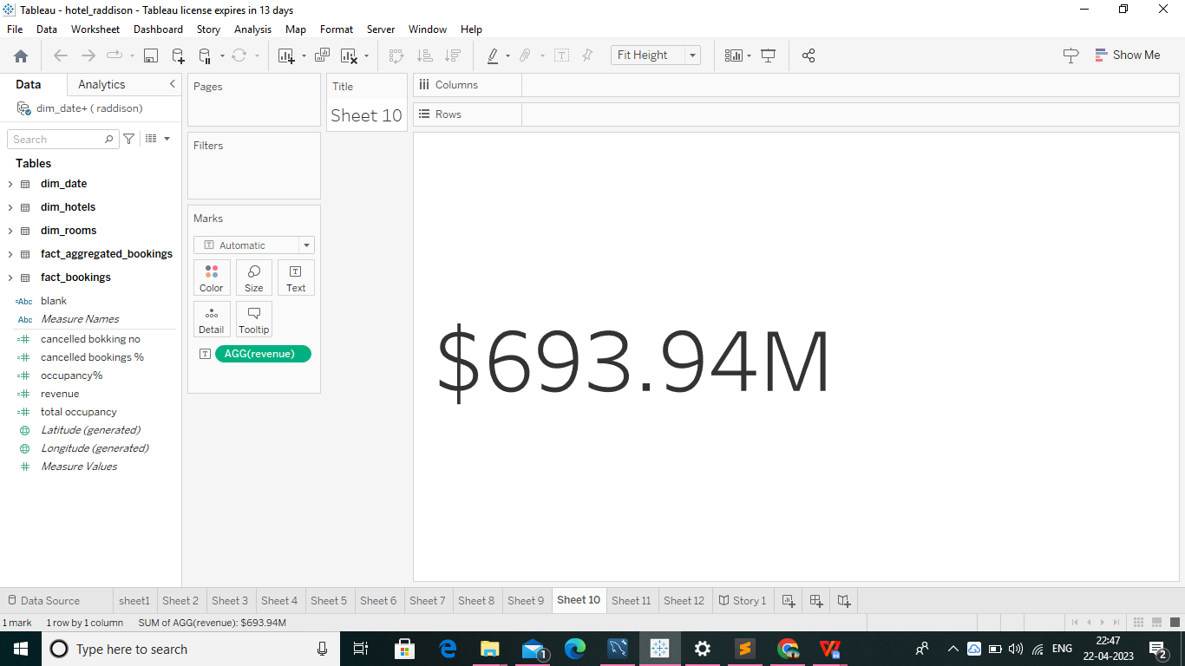

**10.Total Successful Bookings**

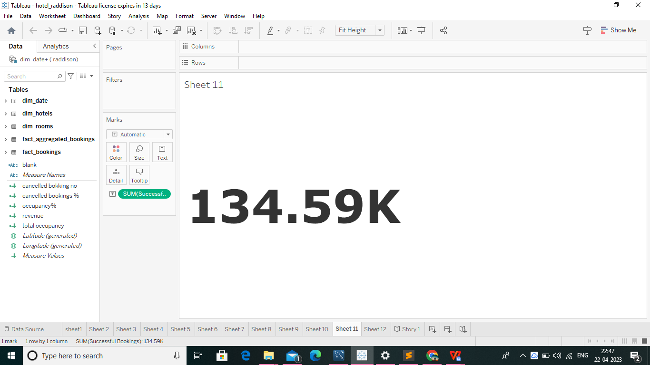

1. ADVANTAGES & DISADVANTAGES

ADVANTAGES :

✓ Identify patterns and trends: Data visualization techniques can help identify patterns and trends in the performance of the hotel. For example, by analyzing occupancy rates, revenue per available room (RevPAR), and other metrics, managers can see how the hotel's performance varies over time and identify areas for improvement.

✓ Enhance decision-making: Data visualization can help managers make informed decisions by providing a visual representation of complex data. By presenting data in an easy-to-understand format, managers can quickly identify areas that need attention and make more informed decisions.

✓ Improve communication: Data visualization techniques can improve communication among stakeholders. By presenting data in an easily understandable format, managers can effectively communicate performance metrics and progress to investors, employees, and other stakeholders. Overall, data visualization techniques can help hotels to make better decisions, improve the customer experience, optimize resource allocation, improve operational efficiency, and gain a competitive advantage.

DISADVANTAGES :

✓ Limited scope: Data visualization techniques can only represent the data that has been collected, and may not provide a complete view of the hotel's performance. For example, if certain metrics are not being tracked or recorded, they will not be included in the analysis.

✓ Misleading representation: Data visualization can be misleading if not done properly, and can distort or exaggerate certain aspects of the data. This can lead to incorrect conclusions and poor decision-making.

✓ Complexity: Data visualization techniques can be complex and require specialized skills and knowledge. This can make it difficult to implement and maintain effective data visualization practices, particularly for smaller hotels or those with limited resources. Overall, while data visualization techniques can offer valuable insights into the performance and efficiency of Radisson Hotels, it is important to consider these potential disadvantages and carefully weigh the benefits against the costs and risks.

1. APPLICATIONS

• Revenue management: Data visualization can be used to analyze data on occupancy rates, room rates, and customer demand to optimize revenue management. By identifying patterns and trends in customer behavior, hotels can adjust their pricing and inventory strategies to maximize revenue.

• Customer satisfaction: Data visualization techniques can be used to analyze customer feedback and satisfaction surveys to identify areas where the hotel is excelling or falling short. This information can be used to make necessary changes and improvements to enhance the customer experience.

• Operational efficiency: Data visualization can be used to analyze data on operational metrics such as labor costs, maintenance expenses, and energy usage to identify areas where the hotel can improve its operational efficiency. By making necessary changes, hotels can reduce costs and improve profitability.

Overall, data visualization techniques can be applied to various areas of hotel management to improve revenue management, customer satisfaction, operational efficiency, marketing and advertising, and risk management.

1. CONCLUSION

In conclusion, the performance and efficiency of Radisson Hotels were analyzed using data visualization techniques. Various key performance indicators such as occupancy rate, ADR, and RevPAR were analyzed and visualized using different charts and graphs. The analysis revealed that the Radisson Hotels had a stable occupancy rate, a moderate ADR, and a fluctuating RevPAR over the period of analysis. Furthermore, the analysis also showed that the Radisson Hotels had a higher occupancy rate and RevPAR during weekends and a lower occupancy rate and RevPAR during weekdays. Additionally, the performance of different hotels in different regions was also analyzed, and it was found that some hotels were performing better than others. Overall, the data visualization techniques used in the analysis provided insights into the performance and efficiency of Radisson Hotels, which can be used by the management to make informed decisions and improve their business operations.

1. FUTURE SCOPE

There are several enhancements that can be made in the future of analyzing the performance and efficiency of Radisson Hotels using data visualization techniques. Here are a few:

➢ Real-time data visualization: Radisson Hotels can use real-time data visualization techniques to monitor their performance and efficiency in real-time. This will enable them to identify issues and take corrective measures in a timely manner.

➢ Interactive dashboards: Interactive dashboards can be developed that will allow users to interact with the data and gain insights based on their specific requirements. These dashboards can be customized to show only relevant data and KPIs.

➢ Predictive analytics: Predictive analytics can be used to forecast future trends and identify potential issues that may impact the performance and efficiency of Radisson Hotels. This can help them take proactive measures to mitigate these issues.

➢ Mobile-friendly visualizations: Mobile-friendly visualizations can be developed that will allow users to access the data on their mobile devices. This will enable them to monitor the performance and efficiency of Radisson Hotels on-the-go.

➢ Integration with other data sources: Radisson Hotels can integrate their data with other data sources such as social media and customer feedback platforms. This will enable them to gain a holistic view of their performance and efficiency and identify areas for improvement. ➢ Automated reporting: Automated reporting can be developed that will generate reports automatically based on predefined KPIs. This will save time and effort and enable users to focus on analyzing the data rather than generating reports.

➢ AI-powered insights: AI-powered insights can be developed that will analyze the data and provide actionable insights to users. This can help Radisson Hotels make informed decisions and improve their performance and efficiency. Overall, these enhancements can help Radisson Hotels gain a competitive advantage by improving their performance and efficiency and delivering a superior customer experience.

**APPENDIX:**

**CODING:**

**<!DOCTYPE html>**

**<html lang="en">**

**<head>**

**<meta charset="utf-8">**

**<meta content="width=device-width, initial-scale=1.0" name="viewport">**

**<title>Hotle Raddison </title>**

**<meta content="" name="description">**

**<meta content="" name="keywords">**

**<!-- Favicons -->**

**<link href="assets/img/favicon.png" rel="icon">**

**<link href="assets/img/apple-touch-icon.png" rel="apple-touch-icon">**

**<!-- Google Fonts -->**

**<link href="https://fonts.googleapis.com/css?family=Open+Sans:300,300i,400,400i,600,600i,700,700i|Raleway:300,300i,400,400i,500,500i,600,600i,700,700i|Poppins:300,300i,400,400i,500,500i,600,600i,700,700i" rel="stylesheet">**

**<!-- Vendor CSS Files -->**

**<link href="assets/vendor/aos/aos.css" rel="stylesheet">**

**<link href="assets/vendor/bootstrap/css/bootstrap.min.css" rel="stylesheet">**

**<link href="assets/vendor/bootstrap-icons/bootstrap-icons.css" rel="stylesheet">**

**<link href="assets/vendor/boxicons/css/boxicons.min.css" rel="stylesheet">**

**<link href="assets/vendor/glightbox/css/glightbox.min.css" rel="stylesheet">**

**<link href="assets/vendor/swiper/swiper-bundle.min.css" rel="stylesheet">**

**<!-- Template Main CSS File -->**

**<link href="assets/css/style.css" rel="stylesheet">**

**<!-- =======================================================**

**\* Template Name: Hotle radison**

**\* Updated: Mar 10 2023 with Bootstrap v5.2.3**

**\* Template URL: https://bootstrapmade.com/Hotle radison-multipurpose-html-template-for-free/**

**\* Author: BootstrapMade.com**

**\* License: https://bootstrapmade.com/license/**

**======================================================== -->**

**</head>**

**<body>**

**<!-- ======= Top Bar ======= -->**

**<section id="topbar" class="d-flex align-items-center">**

**<div class="container d-flex justify-content-center justify-content-md-between">**

**<div class="contact-info d-flex align-items-center">**

**<i class="bi bi-envelope-fill"></i><a href="mailto:contact@example.com">shivashakthi303@gmail.com</a>**

**<i class="bi bi-phone-fill phone-icon"></i> +919344619303**

**</div>**

**<div class="social-links d-none d-md-block">**

**<a href="#" class="twitter"><i class="bi bi-twitter"></i></a>**

**<a href="#" class="facebook"><i class="bi bi-facebook"></i></a>**

**<a href="#" class="instagram"><i class="bi bi-instagram"></i></a>**

**<a href="#" class="linkedin"><i class="bi bi-linkedin"></i></i></a>**

**</div>**

**</div>**

**</section>**

**<!-- ======= Header ======= -->**

**<header id="header" class="d-flex align-items-center">**

**<div class="container d-flex align-items-center justify-content-between">**

**<h1 class="logo"><a href="index.html"Hotle radison</a></h1>**

**<!-- Uncomment below if you prefer to use an image logo -->**

**<!-- <a href="index.html" class="logo"><img src="assets/img/logo.png" alt="" class="img-fluid"></a>-->**

**<nav id="navbar" class="navbar">**

**<ul>**

**<li><a class="nav-link scrollto active" href="#hero">Home</a></li>**

**<li><a class="nav-link scrollto" href="#about">About</a></li>**

**<li><a class="nav-link scrollto" href="#services">Services</a></li>**

**<li><a class="nav-link scrollto " href="#portfolio">Portfolio</a></li>**

**<li><a class="nav-link scrollto" href="#pricing">Pricing</a></li>**

**<li><a class="nav-link scrollto" href="#team">Team</a></li>**

**<li class="dropdown"><a href="#"><span>Drop Down</span> <i class="bi bi-chevron-down"></i></a>**

**<ul>**

**<li><a href="#">Drop Down 1</a></li>**

**<li class="dropdown"><a href="#"><span>Deep Drop Down</span> <i class="bi bi-chevron-right"></i></a>**

**<ul>**

**<li><a href="#">Deep Drop Down 1</a></li>**

**<li><a href="#">Deep Drop Down 2</a></li>**

**<li><a href="#">Deep Drop Down 3</a></li>**

**<li><a href="#">Deep Drop Down 4</a></li>**

**<li><a href="#">Deep Drop Down 5</a></li>**

**</ul>**

**</li>**

**<li><a href="#">Drop Down 2</a></li>**

**<li><a href="#">Drop Down 3</a></li>**

**<li><a href="#">Drop Down 4</a></li>**

**</ul>**

**</li>**

**<li><a class="nav-link scrollto" href="#contact">Contact</a></li>**

**</ul>**

**<i class="bi bi-list mobile-nav-toggle"></i>**

**</nav><!-- .navbar -->**

**</div>**

**</header><!-- End Header -->**

**<!-- ======= Hero Section ======= -->**

**<section id="hero" class="d-flex align-items-center">**

**<div class="container position-relative" data-aos="fade-up" data-aos-delay="500">**

**<h1>Welcome to Hotle radison</h1>**

**<h2>We are team of talented designers making websites with Bootstrap</h2>**

**<a href="#about" class="btn-get-started scrollto">Get Started</a>**

**</div>**

**</section><!-- End Hero -->**

**<main id="main">**

**<!-- ======= About Section ======= -->**

**<section id="about" class="about">**

**<div class="container">**

**<div class="row">**

**<div class="col-lg-6 order-1 order-lg-2" data-aos="fade-left">**

**<img src="assets/img/about.jpg" class="img-fluid" alt="">**

**</div>**

**<div class="col-lg-6 pt-4 pt-lg-0 order-2 order-lg-1 content" data-aos="fade-right">**

**<h3>Voluptatem dignissimos provident quasi corporis voluptates sit assumenda.</h3>**

**<p class="fst-italic">**

**Lorem ipsum dolor sit amet, consectetur adipiscing elit, sed do eiusmod tempor incididunt ut labore et dolore**

**magna aliqua.**

**</p>**

**<ul>**

**<li><i class="bi bi-check-circle"></i> Ullamco laboris nisi ut aliquip ex ea commodo consequat.</li>**

**<li><i class="bi bi-check-circle"></i> Duis aute irure dolor in reprehenderit in voluptate velit.</li>**

**<li><i class="bi bi-check-circle"></i> Ullamco laboris nisi ut aliquip ex ea commodo consequat. Duis aute irure dolor in reprehenderit in voluptate trideta storacalaperda mastiro dolore eu fugiat nulla pariatur.</li>**

**</ul>**

**<p>**

**Ullamco laboris nisi ut aliquip ex ea commodo consequat. Duis aute irure dolor in reprehenderit in voluptate**

**velit esse cillum dolore eu fugiat nulla pariatur. Excepteur sint occaecat cupidatat non proident, sunt in**

**culpa qui officia deserunt mollit anim id est laborum**

**</p>**

**</div>**

**</div>**

**</div>**

**</section><!-- End About Section -->**

**<!-- ======= Why Us Section ======= -->**

**<section id="why-us" class="why-us">**

**<div class="container">**

**<div class="row">**

**<div class="col-lg-4" data-aos="fade-up">**

**<div class="box">**

**<span>01</span>**

**<h4>Lorem Ipsum</h4>**

**<p>Ulamco laboris nisi ut aliquip ex ea commodo consequat. Et consectetur ducimus vero placeat</p>**

**</div>**

**</div>**

**<div class="col-lg-4 mt-4 mt-lg-0" data-aos="fade-up" data-aos-delay="150">**

**<div class="box">**

**<span>02</span>**

**<h4>Repellat Nihil</h4>**

**<p>Dolorem est fugiat occaecati voluptate velit esse. Dicta veritatis dolor quod et vel dire leno para dest</p>**

**</div>**

**</div>**

**<div class="col-lg-4 mt-4 mt-lg-0" data-aos="fade-up" data-aos-delay="300">**

**<div class="box">**

**<span>03</span>**

**<h4> Ad ad velit qui</h4>**

**<p>Molestiae officiis omnis illo asperiores. Aut doloribus vitae sunt debitis quo vel nam quis</p>**

**</div>**

**</div>**

**</div>**

**</div>**

**</section><!-- End Why Us Section -->**

**<!-- ======= Clients Section ======= -->**

**<section id="clients" class="clients">**

**<div class="container" data-aos="zoom-in">**

**<div class="row d-flex align-items-center">**

**<div class="col-lg-2 col-md-4 col-6">**

**<img src="assets/img/clients/client-1.png" class="img-fluid" alt="">**

**</div>**

**<div class="col-lg-2 col-md-4 col-6">**

**<img src="assets/img/clients/client-2.png" class="img-fluid" alt="">**

**</div>**

**<div class="col-lg-2 col-md-4 col-6">**

**<img src="assets/img/clients/client-3.png" class="img-fluid" alt="">**

**</div>**

**<div class="col-lg-2 col-md-4 col-6">**

**<img src="assets/img/clients/client-4.png" class="img-fluid" alt="">**

**</div>**

**<div class="col-lg-2 col-md-4 col-6">**

**<img src="assets/img/clients/client-5.png" class="img-fluid" alt="">**

**</div>**

**<div class="col-lg-2 col-md-4 col-6">**

**<img src="assets/img/clients/client-6.png" class="img-fluid" alt="">**

**</div>**

**</div>**

**</div>**

**</section><!-- End Clients Section -->**

**<!-- ======= Services Section ======= -->**

**<section id="services" class="services">**

**<div class="container">**

**<div class="section-title">**

**<span>Services</span>**

**<h2>Services</h2>**

**<p>Sit sint consectetur velit quisquam cupiditate impedit suscipit alias</p>**

**</div>**

**<div class="row">**

**<div class="col-lg-4 col-md-6 d-flex align-items-stretch" data-aos="fade-up">**

**<div class="icon-box">**

**<div class="icon"><i class="bx bxl-dribbble"></i></div>**

**<h4><a href="">Lorem Ipsum</a></h4>**

**<p>Voluptatum deleniti atque corrupti quos dolores et quas molestias excepturi</p>**

**</div>**

**</div>**

**<div class="col-lg-4 col-md-6 d-flex align-items-stretch mt-4 mt-md-0" data-aos="fade-up" data-aos-delay="150">**

**<div class="icon-box">**

**<div class="icon"><i class="bx bx-file"></i></div>**

**<h4><a href="">Sed ut perspiciatis</a></h4>**

**<p>Duis aute irure dolor in reprehenderit in voluptate velit esse cillum dolore</p>**

**</div>**

**</div>**

**<div class="col-lg-4 col-md-6 d-flex align-items-stretch mt-4 mt-lg-0" data-aos="fade-up" data-aos-delay="300">**

**<div class="icon-box">**

**<div class="icon"><i class="bx bx-tachometer"></i></div>**

**<h4><a href="">Magni Dolores</a></h4>**

**<p>Excepteur sint occaecat cupidatat non proident, sunt in culpa qui officia</p>**

**</div>**

**</div>**

**<div class="col-lg-4 col-md-6 d-flex align-items-stretch mt-4" data-aos="fade-up" data-aos-delay="450">**

**<div class="icon-box">**

**<div class="icon"><i class="bx bx-world"></i></div>**

**<h4><a href="">Nemo Enim</a></h4>**

**<p>At vero eos et accusamus et iusto odio dignissimos ducimus qui blanditiis</p>**

**</div>**

**</div>**

**<div class="col-lg-4 col-md-6 d-flex align-items-stretch mt-4" data-aos="fade-up" data-aos-delay="600">**

**<div class="icon-box">**

**<div class="icon"><i class="bx bx-slideshow"></i></div>**

**<h4><a href="">Dele cardo</a></h4>**

**<p>Quis consequatur saepe eligendi voluptatem consequatur dolor consequuntur</p>**

**</div>**

**</div>**

**<div class="col-lg-4 col-md-6 d-flex align-items-stretch mt-4" data-aos="fade-up" data-aos-delay="750">**

**<div class="icon-box">**

**<div class="icon"><i class="bx bx-arch"></i></div>**

**<h4><a href="">Divera don</a></h4>**

**<p>Modi nostrum vel laborum. Porro fugit error sit minus sapiente sit aspernatur</p>**

**</div>**

**</div>**

**</div>**

**</div>**

**</section><!-- End Services Section -->**

**<!-- ======= Cta Section ======= -->**

**<section id="cta" class="cta">**

**<div class="container" data-aos="zoom-in">**

**<div class="text-center">**

**<h3>Call To Action</h3>**

**<p> Duis aute irure dolor in reprehenderit in voluptate velit esse cillum dolore eu fugiat nulla pariatur. Excepteur sint occaecat cupidatat non proident, sunt in culpa qui officia deserunt mollit anim id est laborum.</p>**

**<a class="cta-btn" href="#">Call To Action</a>**

**</div>**

**</div>**

**</section><!-- End Cta Section -->**

**<!-- ======= Portfolio Section ======= -->**

**<section id="portfolio" class="portfolio">**

**<div class="container">**

**<div class="section-title">**

**<span>Portfolio</span>**

**<h2>Portfolio</h2>**

**<p>Sit sint consectetur velit quisquam cupiditate impedit suscipit alias</p>**

**</div>**

**<div class="row" data-aos="fade-up">**

**<div class="col-lg-12 d-flex justify-content-center">**

**<ul id="portfolio-flters">**

**<li data-filter="*" class="filter-active">All</li>**

**<li data-filter=".filter-app">App</li>**

**<li data-filter=".filter-card">Card</li>**

**<li data-filter=".filter-web">Web</li>**

**</ul>**

**</div>**

**</div>**

**<div class="row portfolio-container" data-aos="fade-up" data-aos-delay="150">**

**<div class="col-lg-4 col-md-6 portfolio-item filter-app">**

**<img src="assets/img/portfolio/portfolio-1.jpg" class="img-fluid" alt="">**

**<div class="portfolio-info">**

**<h4>App 1</h4>**

**<p>App</p>**

**<a href="assets/img/portfolio/portfolio-1.jpg" data-gallery="portfolioGallery" class="portfolio-lightbox preview-link" title="App 1"><i class="bx bx-plus"></i></a>**

**<a href="portfolio-details.html" class="details-link" title="More Details"><i class="bx bx-link"></i></a>**

**</div>**

**</div>**

**<div class="col-lg-4 col-md-6 portfolio-item filter-web">**

**<img src="assets/img/portfolio/portfolio-2.jpg" class="img-fluid" alt="">**

**<div class="portfolio-info">**

**<h4>Web 3</h4>**

**<p>Web</p>**

**<a href="assets/img/portfolio/portfolio-2.jpg" data-gallery="portfolioGallery" class="portfolio-lightbox preview-link" title="Web 3"><i class="bx bx-plus"></i></a>**

**<a href="portfolio-details.html" class="details-link" title="More Details"><i class="bx bx-link"></i></a>**

**</div>**

**</div>**

**<div class="col-lg-4 col-md-6 portfolio-item filter-app">**

**<img src="assets/img/portfolio/portfolio-3.jpg" class="img-fluid" alt="">**

**<div class="portfolio-info">**

**<h4>App 2</h4>**

**<p>App</p>**

**<a href="assets/img/portfolio/portfolio-3.jpg" data-gallery="portfolioGallery" class="portfolio-lightbox preview-link" title="App 2"><i class="bx bx-plus"></i></a>**

**<a href="portfolio-details.html" class="details-link" title="More Details"><i class="bx bx-link"></i></a>**

**</div>**

**</div>**

**<div class="col-lg-4 col-md-6 portfolio-item filter-card">**

**<img src="assets/img/portfolio/portfolio-4.jpg" class="img-fluid" alt="">**

**<div class="portfolio-info">**

**<h4>Card 2</h4>**

**<p>Card</p>**

**<a href="assets/img/portfolio/portfolio-4.jpg" data-gallery="portfolioGallery" class="portfolio-lightbox preview-link" title="Card 2"><i class="bx bx-plus"></i></a>**

**<a href="portfolio-details.html" class="details-link" title="More Details"><i class="bx bx-link"></i></a>**

**</div>**

**</div>**

**<div class="col-lg-4 col-md-6 portfolio-item filter-web">**

**<img src="assets/img/portfolio/portfolio-5.jpg" class="img-fluid" alt="">**

**<div class="portfolio-info">**

**<h4>Web 2</h4>**

**<p>Web</p>**

**<a href="assets/img/portfolio/portfolio-5.jpg" data-gallery="portfolioGallery" class="portfolio-lightbox preview-link" title="Web 2"><i class="bx bx-plus"></i></a>**

**<a href="portfolio-details.html" class="details-link" title="More Details"><i class="bx bx-link"></i></a>**

**</div>**

**</div>**

**<div class="col-lg-4 col-md-6 portfolio-item filter-app">**

**<img src="assets/img/portfolio/portfolio-6.jpg" class="img-fluid" alt="">**

**<div class="portfolio-info">**

**<h4>App 3</h4>**

**<p>App</p>**

**<a href="assets/img/portfolio/portfolio-6.jpg" data-gallery="portfolioGallery" class="portfolio-lightbox preview-link" title="App 3"><i class="bx bx-plus"></i></a>**

**<a href="portfolio-details.html" class="details-link" title="More Details"><i class="bx bx-link"></i></a>**

**</div>**

**</div>**

**<div class="col-lg-4 col-md-6 portfolio-item filter-card">**

**<img src="assets/img/portfolio/portfolio-7.jpg" class="img-fluid" alt="">**

**<div class="portfolio-info">**

**<h4>Card 1</h4>**

**<p>Card</p>**

**<a href="assets/img/portfolio/portfolio-7.jpg" data-gallery="portfolioGallery" class="portfolio-lightbox preview-link" title="Card 1"><i class="bx bx-plus"></i></a>**

**<a href="portfolio-details.html" class="details-link" title="More Details"><i class="bx bx-link"></i></a>**

**</div>**

**</div>**

**<div class="col-lg-4 col-md-6 portfolio-item filter-card">**

**<img src="assets/img/portfolio/portfolio-8.jpg" class="img-fluid" alt="">**

**<div class="portfolio-info">**

**<h4>Card 3</h4>**

**<p>Card</p>**

**<a href="assets/img/portfolio/portfolio-8.jpg" data-gallery="portfolioGallery" class="portfolio-lightbox preview-link" title="Card 3"><i class="bx bx-plus"></i></a>**

**<a href="portfolio-details.html" class="details-link" title="More Details"><i class="bx bx-link"></i></a>**

**</div>**

**</div>**

**<div class="col-lg-4 col-md-6 portfolio-item filter-web">**

**<img src="assets/img/portfolio/portfolio-9.jpg" class="img-fluid" alt="">**

**<div class="portfolio-info">**

**<h4>Web 3</h4>**

**<p>Web</p>**

**<a href="assets/img/portfolio/portfolio-9.jpg" data-gallery="portfolioGallery" class="portfolio-lightbox preview-link" title="Web 3"><i class="bx bx-plus"></i></a>**

**<a href="portfolio-details.html" class="details-link" title="More Details"><i class="bx bx-link"></i></a>**

**</div>**

**</div>**

**</div>**

**</div>**

**</section><!-- End Portfolio Section -->**

**<!-- ======= Pricing Section ======= -->**

**<section id="pricing" class="pricing">**

**<div class="container">**

**<div class="section-title">**

**<span>Pricing</span>**

**<h2>Pricing</h2>**

**<p>Sit sint consectetur velit quisquam cupiditate impedit suscipit alias</p>**

**</div>**

**<div class="row">**

**<div class="col-lg-4 col-md-6" data-aos="zoom-in" data-aos-delay="150">**

**<div class="box">**

**<h3>Free</h3>**

**<h4><sup>$</sup>0<span> / month</span></h4>**

**<ul>**

**<li>Aida dere</li>**

**<li>Nec feugiat nisl</li>**

**<li>Nulla at volutpat dola</li>**

**<li class="na">Pharetra massa</li>**

**<li class="na">Massa ultricies mi</li>**

**</ul>**

**<div class="btn-wrap">**

**<a href="#" class="btn-buy">Buy Now</a>**

**</div>**

**</div>**

**</div>**

**<div class="col-lg-4 col-md-6 mt-4 mt-md-0" data-aos="zoom-in">**

**<div class="box featured">**

**<h3>Business</h3>**

**<h4><sup>$</sup>19<span> / month</span></h4>**

**<ul>**

**<li>Aida dere</li>**

**<li>Nec feugiat nisl</li>**

**<li>Nulla at volutpat dola</li>**

**<li>Pharetra massa</li>**

**<li class="na">Massa ultricies mi</li>**

**</ul>**

**<div class="btn-wrap">**

**<a href="#" class="btn-buy">Buy Now</a>**

**</div>**

**</div>**

**</div>**

**<div class="col-lg-4 col-md-6 mt-4 mt-lg-0" data-aos="zoom-in" data-aos-delay="150">**

**<div class="box">**

**<h3>Developer</h3>**

**<h4><sup>$</sup>29<span> / month</span></h4>**

**<ul>**

**<li>Aida dere</li>**

**<li>Nec feugiat nisl</li>**

**<li>Nulla at volutpat dola</li>**

**<li>Pharetra massa</li>**

**<li>Massa ultricies mi</li>**

**</ul>**

**<div class="btn-wrap">**

**<a href="#" class="btn-buy">Buy Now</a>**

**</div>**

**</div>**

**</div>**

**</div>**

**</div>**

**</section><!-- End Pricing Section -->**

**<!-- ======= Team Section ======= -->**

**<section id="team" class="team">**

**<div class="container">**

**<div class="section-title">**

**<span>Team</span>**

**<h2>Team</h2>**

**<p>Sit sint consectetur velit quisquam cupiditate impedit suscipit alias</p>**

**</div>**

**<div class="row">**

**<div class="col-lg-4 col-md-6 d-flex align-items-stretch" data-aos="zoom-in">**

**<div class="member">**

**<img src="assets/img/team/team-1.jpg" alt="">**

**<h4>Walter White</h4>**

**<span>Chief Executive Officer</span>**

**<p>**

**Magni qui quod omnis unde et eos fuga et exercitationem. Odio veritatis perspiciatis quaerat qui aut aut aut**

**</p>**

**<div class="social">**

**<a href=""><i class="bi bi-twitter"></i></a>**

**<a href=""><i class="bi bi-facebook"></i></a>**

**<a href=""><i class="bi bi-instagram"></i></a>**

**<a href=""><i class="bi bi-linkedin"></i></a>**

**</div>**

**</div>**

**</div>**

**<div class="col-lg-4 col-md-6 d-flex align-items-stretch" data-aos="zoom-in">**

**<div class="member">**

**<img src="assets/img/team/team-2.jpg" alt="">**

**<h4>Sarah Jhinson</h4>**

**<span>Product Manager</span>**

**<p>**

**Repellat fugiat adipisci nemo illum nesciunt voluptas repellendus. In architecto rerum rerum temporibus**

**</p>**

**<div class="social">**

**<a href=""><i class="bi bi-twitter"></i></a>**

**<a href=""><i class="bi bi-facebook"></i></a>**

**<a href=""><i class="bi bi-instagram"></i></a>**

**<a href=""><i class="bi bi-linkedin"></i></a>**

**</div>**

**</div>**

**</div>**

**<div class="col-lg-4 col-md-6 d-flex align-items-stretch" data-aos="zoom-in">**

**<div class="member">**

**<img src="assets/img/team/team-3.jpg" alt="">**

**<h4>William Anderson</h4>**

**<span>CTO</span>**

**<p>**

**Voluptas necessitatibus occaecati quia. Earum totam consequuntur qui porro et laborum toro des clara**

**</p>**

**<div class="social">**

**<a href=""><i class="bi bi-twitter"></i></a>**

**<a href=""><i class="bi bi-facebook"></i></a>**

**<a href=""><i class="bi bi-instagram"></i></a>**

**<a href=""><i class="bi bi-linkedin"></i></a>**

**</div>**

**</div>**

**</div>**

**</div>**

**</div>**

**</section><!-- End Team Section -->**

**<!-- ======= Contact Section ======= -->**

**<section id="contact" class="contact">**

**<div class="container">**

**<div class="section-title">**

**<span>Contact</span>**

**<h2>Contact</h2>**

**<p>Sit sint consectetur velit quisquam cupiditate impedit suscipit alias</p>**

**</div>**

**<div class="row" data-aos="fade-up">**

**<div class="col-lg-6">**

**<div class="info-box mb-4">**

**<i class="bx bx-map"></i>**

**<h3>Our Address</h3>**

**<p>A108 Adam Street, New York, NY 535022</p>**

**</div>**

**</div>**

**<div class="col-lg-3 col-md-6">**

**<div class="info-box mb-4">**

**<i class="bx bx-envelope"></i>**

**<h3>Email Us</h3>**

**<p>contact@example.com</p>**

**</div>**

**</div>**

**<div class="col-lg-3 col-md-6">**

**<div class="info-box mb-4">**

**<i class="bx bx-phone-call"></i>**

**<h3>Call Us</h3>**

**<p>+1 5589 55488 55</p>**

**</div>**

**</div>**

**</div>**

**<div class="row" data-aos="fade-up">**

**<div class="col-lg-6 ">**

**<iframe class="mb-4 mb-lg-0" src="https://www.google.com/maps/embed?pb=!1m14!1m8!1m3!1d12097.433213460943!2d-74.0062269!3d40.7101282!3m2!1i1024!2i768!4f13.1!3m3!1m2!1s0x0%3A0xb89d1fe6bc499443!2sDowntown+Conference+Center!5e0!3m2!1smk!2sbg!4v1539943755621" frameborder="0" style="border:0; width: 100%; height: 384px;" allowfullscreen></iframe>**

**</div>**

**<div class="col-lg-6">**

**<form action="forms/contact.php" method="post" role="form" class="php-email-form">**

**<div class="row">**

**<div class="col-md-6 form-group">**

**<input type="text" name="name" class="form-control" id="name" placeholder="Your Name" required>**

**</div>**

**<div class="col-md-6 form-group mt-3 mt-md-0">**

**<input type="email" class="form-control" name="email" id="email" placeholder="Your Email" required>**

**</div>**

**</div>**

**<div class="form-group mt-3">**

**<input type="text" class="form-control" name="subject" id="subject" placeholder="Subject" required>**

**</div>**

**<div class="form-group mt-3">**

**<textarea class="form-control" name="message" rows="5" placeholder="Message" required></textarea>**

**</div>**

**<div class="my-3">**

**<div class="loading">Loading</div>**

**<div class="error-message"></div>**

**<div class="sent-message">Your message has been sent. Thank you!</div>**

**</div>**

**<div class="text-center"><button type="submit">Send Message</button></div>**

**</form>**

**</div>**

**</div>**

**</div>**

**</section><!-- End Contact Section -->**

**</main><!-- End #main -->**

**<!-- ======= Footer ======= -->**

**<footer id="footer">**

**<div class="footer-top">**

**<div class="container">**

**<div class="row">**

**<div class="col-lg-4 col-md-6">**

**<div class="footer-info">**

**<h3>Hotle radison</h3>**

**<p>**

**A108 Adam Street <br>**

**NY 535022, USA<br><br>**

**<strong>Phone:</strong> +919344619303<br>**

**<strong>Email:</strong> shivashakthi303@gmail.com<br>**

**</p>**

**<div class="social-links mt-3">**

**<a href="#" class="twitter"><i class="bx bxl-twitter"></i></a>**

**<a href="#" class="facebook"><i class="bx bxl-facebook"></i></a>**

**<a href="#" class="instagram"><i class="bx bxl-instagram"></i></a>**

**<a href="#" class="google-plus"><i class="bx bxl-skype"></i></a>**

**<a href="#" class="linkedin"><i class="bx bxl-linkedin"></i></a>**

**</div>**

**</div>**

**</div>**

**<div class="col-lg-2 col-md-6 footer-links">**

**<h4>Useful Links</h4>**

**<ul>**

**<li><i class="bx bx-chevron-right"></i> <a href="#">Home</a></li>**

**<li><i class="bx bx-chevron-right"></i> <a href="#">About us</a></li>**

**<li><i class="bx bx-chevron-right"></i> <a href="#">Services</a></li>**

**<li><i class="bx bx-chevron-right"></i> <a href="#">Terms of service</a></li>**

**<li><i class="bx bx-chevron-right"></i> <a href="#">Privacy policy</a></li>**

**</ul>**

**</div>**

**<div class="col-lg-2 col-md-6 footer-links">**

**<h4>Our Services</h4>**

**<ul>**

**<li><i class="bx bx-chevron-right"></i> <a href="#">Web Design</a></li>**

**<li><i class="bx bx-chevron-right"></i> <a href="#">Web Development</a></li>**

**<li><i class="bx bx-chevron-right"></i> <a href="#">Product Management</a></li>**

**<li><i class="bx bx-chevron-right"></i> <a href="#">Marketing</a></li>**

**<li><i class="bx bx-chevron-right"></i> <a href="#">Graphic Design</a></li>**

**</ul>**

**</div>**

**<div class="col-lg-4 col-md-6 footer-newsletter">**

**<h4>Our Newsletter</h4>**

**<p>Tamen quem nulla quae legam multos aute sint culpa legam noster magna</p>**

**<form action="" method="post">**

**<input type="email" name="email"><input type="submit" value="Subscribe">**

**</form>**

**</div>**

**</div>**

**</div>**

**</div>**

**<div class="container">**

**<div class="copyright">**

**&copy; Copyright <strong><span>Hotle radison</span></strong>. All Rights Reserved**

**</div>**

**<div class="credits">**

**<!-- All the links in the footer should remain intact. -->**

**<!-- You can delete the links only if you purchased the pro version. -->**

**<!-- Licensing information: https://bootstrapmade.com/license/ -->**

**<!-- Purchase the pro version with working PHP/AJAX contact form: https://bootstrapmade.com/Hotle radison-multipurpose-html-template-for-free/ -->**

**Designed by <a href="https://bootstrapmade.com/">BootstrapMade</a>**

**</div>**

**</div>**

**</footer><!-- End Footer -->**

**<a href="#" class="back-to-top d-flex align-items-center justify-content-center"><i class="bi bi-arrow-up-short"></i></a>**

**<div id="preloader"></div>**

**<!-- Vendor JS Files -->**

**<script src="assets/vendor/aos/aos.js"></script>**

**<script src="assets/vendor/bootstrap/js/bootstrap.bundle.min.js"></script>**

**<script src="assets/vendor/glightbox/js/glightbox.min.js"></script>**

**<script src="assets/vendor/isotope-layout/isotope.pkgd.min.js"></script>**

**<script src="assets/vendor/swiper/swiper-bundle.min.js"></script>**

**<script src="assets/vendor/php-email-form/validate.js"></script>**

**<!-- Template Main JS File -->**

**<script src="assets/js/main.js"></script>**

**</body>**

**</html>**